# Week 9 Homework:

1. Not all features/ surfaces of our chopper model have draft & radii for plastic injection molding. Go back and add draft to the remaining surfaces, and add radii to all sharp corners.
2. Exercise the robustness of your Mini Chopper model by making the following updates:
   1. Update the Bowl height from 3.35” to 5”. Make sure there are no errors (red features in the feature list). The updated model should look like this:

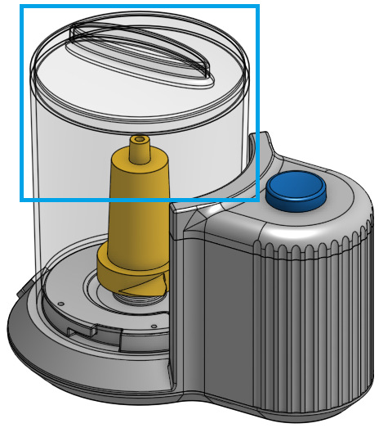

Once it has been confirmed there are no modeling errors, “undo” the update.

* 1. Next, update the major diameter of the design from 5.125” to 5.625” (via the Layout Sketch), and also update the diameter of the bowl from 4.25” to 4.75” (via the Bowl Profile Sketch). Again, make sure there are no errors (red features in the feature list). The updated model should look like this:

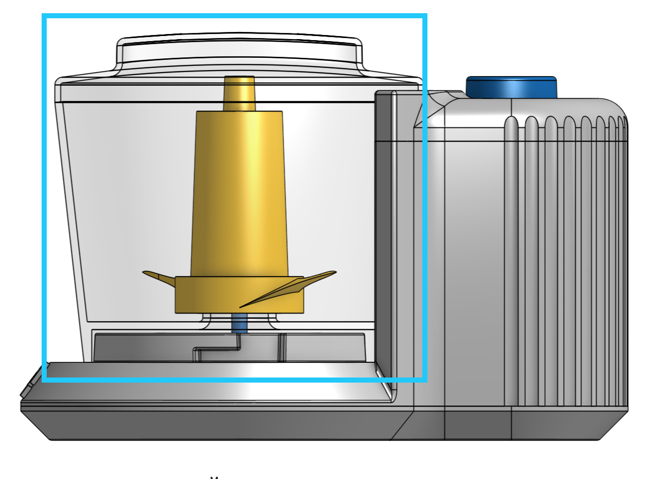

Once it has been confirmed there are no modeling errors, “undo” the update.

1. Update the “THK” variable from .075” to .250”. What happens? Try to methodically go down the feature try and fix all of the errors. (Hint: It’s difficult to shell small radii by a thick amount!). Once all of the errors have been removed, “undo” the update.